**INDIA GENERAL ELECTIONS 2024**

**PROBLEM STATEMENT**

1. TOTAL SEATS
2. TOTAL NO OF SEATS FOR EACH STATE
3. TOTAL SEATS WON BY NDA ALLIANCE
4. SEATS WON BY NDA ALLIANCE PARTIES
5. TOTAL SEATS WON BY INDIAN NATIONAL DEVELOPMENTAL INCLUSIVE ALLIANCE (I.N.D.I.A)
6. TOTAL SEATS WON BY INDIAN NATIONAL DEVELOPMENTAL INCLUSIVE ALLIANCE (I.N.D.I.A) PARTIES
7. ADD A COLUMN FOR PARTY ALLIANCE IN PARTYWISE_RESULTS TABLE
8. WHICH PARTY ALLIANCE WON THE MOST NO OF SEATS ACROSS ALL THE STATES
9. WINNING CANDIDATE'S NAME, THEIR PARTY NAME, TOTAL VOTES, MARGIN OF VICTORY FOR A SPECIFIC STATE AND CONSTITUENCY
10. WHAT IS THE DISTRIBUTION OF EVM VOTES VERSUS POSTAL VOTES FOR CANDIDATES IN A SPECIFIC CONSTITUENCY
11. WHICH PARTY WON THE MOST NUMBER OF SEATS IN A STATE AND HOW MANY SEATS DID EACH PARTY WIN
12. TOTAL NO OF SEATS WON BY EACH PARTY ALLIANCE IN EACH STATE FOR INDIAN ELECTIONS 2024
13. WHICH CANDIDATE RECEIVED THE HIGHEST NUMBER OF EVM VOTES IN EACH CONSTITUENCY (TOP 10)
14. WHICH CANDIDATE WON AND WHICH CANDIDATE WAS A RUNNER UP IN EACH CONSTITUENCY OF STATE
15. FOR THE STATE OF ANDHRA PRADESH, WHAT ARE THE TOTAL NO OF SEATS, TOTAL NO OF CANDIDATES, TOTAL NO OF PARTIES, TOTAL VOTES (INCLUDING EVM AND POSTAL) AND THE BREAKDOWN OF EVM AND POSTAL.
16. **TOTAL SEATS**

SELECT

DISTINCT COUNT(Parliament_Constituency) AS Total_Seats

FROM constituencywise_results;



1. **TOTAL NO OF SEATS FOR EACH STATE**

SELECT

s.state AS State,

COUNT(cr.Parliament_Constituency) AS Total_Seats

FROM constituencywise_results cr

INNER JOIN statewise_results sr ON cr.Parliament_Constituency = sr.Parliament_Constituency

INNER JOIN states s ON sr.state_id = s.state_id

GROUP BY s.state

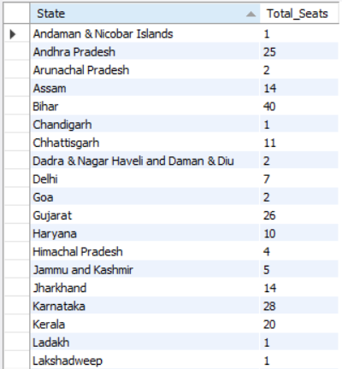 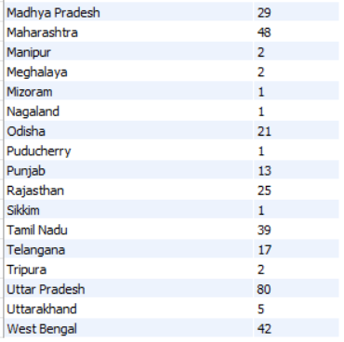

1. **TOTAL SEATS WON BY NDA ALLIANCE**

SELECT

SUM(CASE

WHEN party IN (

'Bharatiya Janata Party - BJP',

'Telugu Desam - TDP',

'Janata Dal (Secular) - JD(S)',

'Janata Dal (United) - JD(U)',

'Shiv Sena - SHS',

'AJSU Party - AJSUP',

'Apna Dal (Soneylal) - ADAL',

'Asom Gana Parishad - AGP',

'Hindustani Awam Morcha (Secular) - HAMS',

'Janasena Party - JnP',

'Lok Janshakti Party(Ram Vilas) - LJPRV',

'Rashtriya Lok Dal - RLD',

'Sikkim Krantikari Morcha - SKM',

'Nationalist Congress Party - NCP'

) THEN Won

ELSE 0

END) AS Total_Seats_Won_By_NDA

FROM partywise_results;

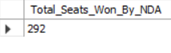

1. **SEATS WON BY NDA ALLIANCE PARTIES**

SELECT

Party, Won as Seats_Won

FROM partywise_results

WHERE party IN

(

'Bharatiya Janata Party - BJP',

'Telugu Desam - TDP',

'Janata Dal (Secular) - JD(S)',

'Janata Dal (United) - JD(U)',

'Shiv Sena - SHS',

'AJSU Party - AJSUP',

'Apna Dal (Soneylal) - ADAL',

'Asom Gana Parishad - AGP',

'Hindustani Awam Morcha (Secular) - HAMS',

'Janasena Party - JnP',

'Lok Janshakti Party(Ram Vilas) - LJPRV',

'Rashtriya Lok Dal - RLD',

'Sikkim Krantikari Morcha - SKM',

'Nationalist Congress Party - NCP'

)

ORDER BY Seats_Won DESC, Party;

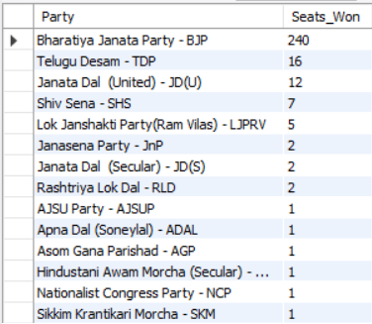

1. **TOTAL SEATS WON BY Indian National Developmental Inclusive Alliance (I.N.D.I.A)**

SELECT SUM(CASE WHEN party in

(

'Indian National Congress - INC',

'Aam Aadmi Party - AAAP',

'All India Trinamool Congress - AITC',

'Bharat Adivasi Party - BHRTADVSIP',

'Communist Party of India (Marxist) - CPI(M)',

'Communist Party of India (Marxist-Leninist) (Liberation) - CPI(ML)(L)',

'Communist Party of India - CPI',

'Dravida Munnetra Kazhagam - DMK',

'Indian Union Muslim League - IUML',

'Nat`Jammu & Kashmir National Conference - JKN',

'Jharkhand Mukti Morcha - JMM',

'Jammu & Kashmir National Conference - JKN',

'Kerala Congress - KEC',

'Marumalarchi Dravida Munnetra Kazhagam - MDMK',

'Nationalist Congress Party Sharadchandra Pawar - NCPSP',

'Rashtriya Janata Dal - RJD',

'Rashtriya Loktantrik Party - RLTP',

'Revolutionary Socialist Party - RSP',

'Samajwadi Party - SP',

'Shiv Sena (Uddhav Balasaheb Thackrey) - SHSUBT',

'Viduthalai Chiruthaigal Katchi - VCK'

)

THEN Won

ELSE 0

END) as Seats_Won_By_INDIAlliance

FROM partywise_results;



1. **TOTAL SEATS WON BY Indian National Developmental Inclusive Alliance (I.N.D.I.A) Parties**

SELECT

Party,

Won as Seats_Won

FROM partywise_results

WHERE party in

(

'Indian National Congress - INC',

'Aam Aadmi Party - AAAP',

'All India Trinamool Congress - AITC',

'Bharat Adivasi Party - BHRTADVSIP',

'Communist Party of India (Marxist) - CPI(M)',

'Communist Party of India (Marxist-Leninist) (Liberation) - CPI(ML)(L)',

'Communist Party of India - CPI',

'Dravida Munnetra Kazhagam - DMK',

'Indian Union Muslim League - IUML',

'Nat`Jammu & Kashmir National Conference - JKN',

'Jharkhand Mukti Morcha - JMM',

'Jammu & Kashmir National Conference - JKN',

'Kerala Congress - KEC',

'Marumalarchi Dravida Munnetra Kazhagam - MDMK',

'Nationalist Congress Party Sharadchandra Pawar - NCPSP',

'Rashtriya Janata Dal - RJD',

'Rashtriya Loktantrik Party - RLTP',

'Revolutionary Socialist Party - RSP',

'Samajwadi Party - SP',

'Shiv Sena (Uddhav Balasaheb Thackrey) - SHSUBT',

'Viduthalai Chiruthaigal Katchi - VCK'

)

ORDER BY Seats_Won Desc, Party;

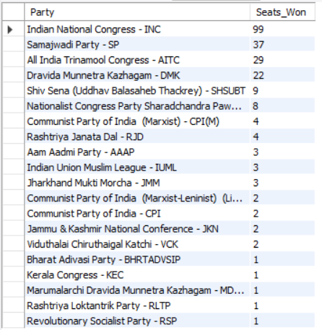

1. **ADD NEW COLUMN IN TABLE PARTYWISE_RESULTS TO GET THE PARTY ALLIANCE AS NDA, I.N.D.I.A AND OTHER**

ALTER TABLE partywise_results ADD Party_Alliance VARCHAR(50);

UPDATE partywise_results SET Party_Alliance = "I.N.D.I.A"

WHERE party IN ('Indian National Congress - INC',

'Aam Aadmi Party - AAAP',

'All India Trinamool Congress - AITC',

'Bharat Adivasi Party - BHRTADVSIP',

'Communist Party of India (Marxist) - CPI(M)',

'Communist Party of India (Marxist-Leninist) (Liberation) - CPI(ML)(L)',

'Communist Party of India - CPI',

'Dravida Munnetra Kazhagam - DMK',

'Indian Union Muslim League - IUML',

'Nat`Jammu & Kashmir National Conference - JKN',

'Jharkhand Mukti Morcha - JMM',

'Jammu & Kashmir National Conference - JKN',

'Kerala Congress - KEC',

'Marumalarchi Dravida Munnetra Kazhagam - MDMK',

'Nationalist Congress Party Sharadchandra Pawar - NCPSP',

'Rashtriya Janata Dal - RJD',

'Rashtriya Loktantrik Party - RLTP',

'Revolutionary Socialist Party - RSP',

'Samajwadi Party - SP',

'Shiv Sena (Uddhav Balasaheb Thackrey) - SHSUBT',

'Viduthalai Chiruthaigal Katchi - VCK'

);

UPDATE partywise_results SET Party_Alliance = "NDA"

WHERE party IN (

'Bharatiya Janata Party - BJP',

'Telugu Desam - TDP',

'Janata Dal (Secular) - JD(S)',

'Janata Dal (United) - JD(U)',

'Shiv Sena - SHS',

'AJSU Party - AJSUP',

'Apna Dal (Soneylal) - ADAL',

'Asom Gana Parishad - AGP',

'Hindustani Awam Morcha (Secular) - HAMS',

'Janasena Party - JnP',

'Lok Janshakti Party(Ram Vilas) - LJPRV',

'Rashtriya Lok Dal - RLD',

'Sikkim Krantikari Morcha - SKM',

'Nationalist Congress Party - NCP'

);

UPDATE partywise_results SET Party_Alliance = "OTHER"

WHERE Party_Alliance IS NULL;

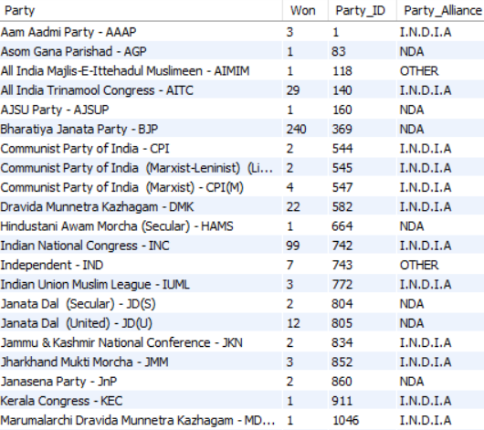

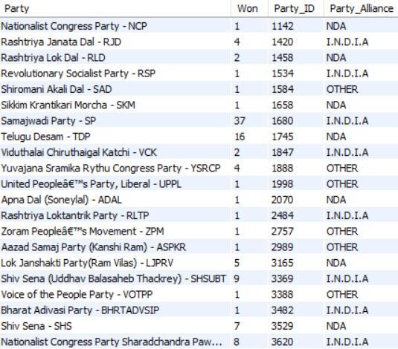

1. **WHICH PARTY ALLIANCE WON THE MOST NO OF SEATS ACROSS ALL THE STATES**

SELECT

Party_Alliance, SUM(Won) as Seats_Won

FROM partywise_results

GROUP BY Party_Alliance

ORDER BY SUM(WON) DESC

LIMIT 1;



1. **WINNING CANDIDATE'S NAME, THEIR PARTY NAME, TOTAL VOTES, MARGIN OF VICTORY FOR A SPECIFIC STATE AND CONSTITUENCY**

SELECT

CR.WINNING_CANDIDATE, PR.PARTY, PR.PARTY_ALLIANCE, CR.TOTAL_VOTES, CR.MARGIN, S.STATE, CR.CONSTITUENCY_NAME

FROM CONSTITUENCYWISE_RESULTS CR

INNER JOIN PARTYWISE_RESULTS PR ON CR.PARTY_ID = PR.PARTY_ID

INNER JOIN STATEWISE_RESULTS SR ON CR.PARLIAMENT_CONSTITUENCY = SR.PARLIAMENT_CONSTITUENCY

INNER JOIN STATES S ON SR.STATE_ID = S.STATE_ID

WHERE CR.CONSTITUENCY_NAME = "ANAKAPALLE";



1. **WHAT IS THE DISTRIBUTION OF EVM VOTES VS POSTAL VOTES FOR CANDIDATES IN A SPECIFIC CONSTITUENCY**

SELECT

CD.CANDIDATE, CD.EVM_VOTES, CD.POSTAL_VOTES, CD.TOTAL_VOTES, CR.CONSTITUENCY_NAME

FROM CONSTITUENCYWISE_DETAILS CD

JOIN CONSTITUENCYWISE_RESULTS CR ON CR.CONSTITUENCY_ID = CD.CONSTITUENCY_ID

WHERE CR.CONSTITUENCY_NAME = "ANAKAPALLE";

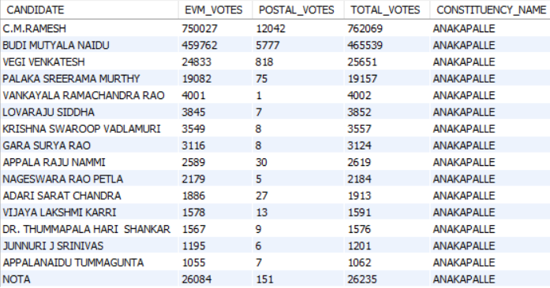

1. **WHICH PARTIES WON THE MOST NUMBER OF SEATS IN A STATE AND HOW MANY SEATS DID EACH PARTY WIN**

SELECT

PR.PARTY, COUNT(CR.CONSTITUENCY_ID) AS SEATS_WON

FROM PARTYWISE_RESULTS PR

INNER JOIN CONSTITUENCYWISE_RESULTS CR ON PR.PARTY_ID = CR.PARTY_ID

INNER JOIN STATEWISE_RESULTS SR ON CR.PARLIAMENT_CONSTITUENCY = SR.PARLIAMENT_CONSTITUENCY

INNER JOIN STATES S ON SR.STATE_ID = S.STATE_ID

WHERE S.STATE = 'ANDHRA PRADESH'

GROUP BY PR.PARTY

ORDER BY SEATS_WON DESC;

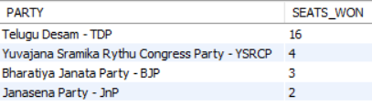

1. **TOTAL NO OF SEATS WON BY EACH PARTY ALLIANCE IN EACH STATE FOR INDIAN ELECTIONS 2024**

SELECT

S.STATE,

SUM(CASE WHEN PR.PARTY_ALLIANCE = 'NDA' THEN 1 ELSE 0 END) AS NDA_SEATS_WON,

SUM(CASE WHEN PR.PARTY_ALLIANCE = 'I.N.D.I.A' THEN 1 ELSE 0 END) AS INDIA_SEATS_WON,

SUM(CASE WHEN PR.PARTY_ALLIANCE = 'OTHER' THEN 1 ELSE 0 END) AS OTHER_SEATS_WON

FROM PARTYWISE_RESULTS PR

INNER JOIN CONSTITUENCYWISE_RESULTS CR ON PR.PARTY_ID = CR.PARTY_ID

INNER JOIN STATEWISE_RESULTS SR ON CR.PARLIAMENT_CONSTITUENCY = SR.PARLIAMENT_CONSTITUENCY

INNER JOIN STATES S ON SR.STATE_ID = S.STATE_ID

GROUP BY S.STATE;

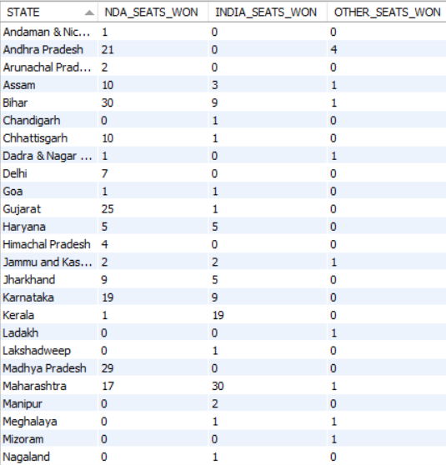 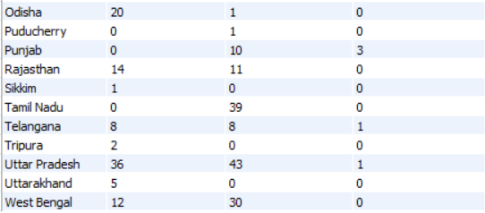

1. **WHICH CANDIDATE RECEIVED THE HIGHEST NUMBER OF EVM VOTES IN EACH CONSTITUENCY (TOP 10)**

SELECT

CD.CANDIDATE, CD.CONSTITUENCY_ID, CR.CONSTITUENCY_NAME, CD.EVM_VOTES

FROM CONSTITUENCYWISE_DETAILS CD

JOIN CONSTITUENCYWISE_RESULTS CR ON CD.CONSTITUENCY_ID = CR.CONSTITUENCY_ID

WHERE

CD.EVM_VOTES =

(

SELECT MAX(CD1.EVM_VOTES)

FROM CONSTITUENCYWISE_DETAILS CD1

WHERE CD.CONSTITUENCY_ID = CD1.CONSTITUENCY_ID

)

ORDER BY CD.EVM_VOTES DESC LIMIT 10;

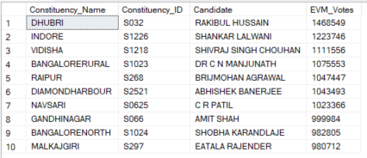

1. **WHICH CANDIDATE WON AND WHICH CANDIDATE WAS A RUNNER UP IN EACH CONSTITUENCY OF STATE**

WITH RANKED_CANDIDATES AS

(

SELECT CD.CONSTITUENCY_ID, CD.CANDIDATE, CD.PARTY, CD.EVM_VOTES, CD.POSTAL_VOTES, CD.TOTAL_VOTES,

ROW_NUMBER() OVER

(

PARTITION BY CD.CONSTITUENCY_ID ORDER BY CD.TOTAL_VOTES DESC

) AS VOTE_RANK

FROM CONSTITUENCYWISE_DETAILS CD

JOIN CONSTITUENCYWISE_RESULTS CR ON CD.CONSTITUENCY_ID = CR.CONSTITUENCY_ID

JOIN STATEWISE_RESULTS SR ON CR.PARLIAMENT_CONSTITUENCY = SR.PARLIAMENT_CONSTITUENCY

JOIN STATES S ON SR.STATE_ID = S.STATE_ID

WHERE S.STATE = 'ANDHRA PRADESH'

)

SELECT

CR.CONSTITUENCY_NAME,

MAX(CASE WHEN RC.VOTE_RANK = 1 THEN RC.CANDIDATE END) AS WINNING_CANDIDATE,

MAX(CASE WHEN RC.VOTE_RANK = 2 THEN RC.CANDIDATE END) AS RUNNING_CANDIDATE

FROM RANKED_CANDIDATES RC

JOIN CONSTITUENCYWISE_RESULTS CR ON RC.CONSTITUENCY_ID = CR.CONSTITUENCY_ID

GROUP BY CR.CONSTITUENCY_NAME

ORDER BY CR.CONSTITUENCY_NAME;

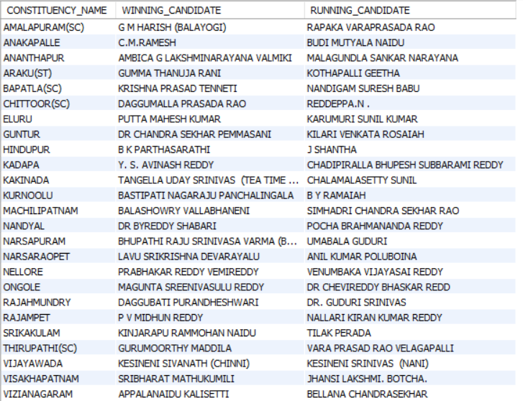

1. **FOR THE STATE OF ANDHRA PRADESH, WHAT ARE THE TOTAL NO OF SEATS, TOTAL NO OF CANDIDATES, TOTAL NO OF PARTIES, TOTAL VOTES (INCLUDING EVM AND POSTAL) AND THE BREAKDOWN OF EVM AND POSTAL.**

SELECT

COUNT(DISTINCT CD.CONSTITUENCY_ID) AS TOTAL_SEATS,

COUNT(DISTINCT CD.CANDIDATE) AS TOTAL_CANDIDATES,

COUNT(DISTINCT CD.PARTY) AS TOTAL_PARTIES,

SUM(CD.TOTAL_VOTES) AS TOTAL_VOTES,

SUM(CD.EVM_VOTES) AS EVM_VOTES,

SUM(CD.POSTAL_VOTES) AS POSTAL_VOTES

FROM CONSTITUENCYWISE_DETAILS CD

JOIN CONSTITUENCYWISE_RESULTS CR ON CD.CONSTITUENCY_ID = CR.CONSTITUENCY_ID

JOIN STATEWISE_RESULTS SR ON CR.PARLIAMENT_CONSTITUENCY = SR.PARLIAMENT_CONSTITUENCY

JOIN STATES S ON SR.STATE_ID = S.STATE_ID

WHERE S.STATE = "ANDHRA PRADESH";

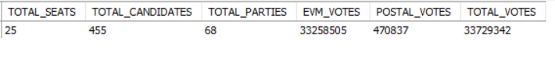

THANK YOU FOR YOUR TIME. 😊

-Jyothsna Sontyana